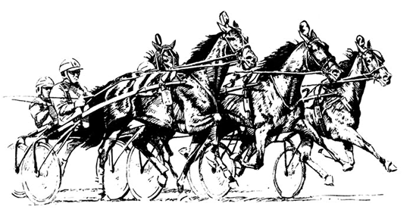

West End Bar & Grill Race Day Menu

Bacon Cheeseburger Platter
Smoked Bacon, Dairy Isle Cheese, Lettuce, Mayo, Tomato, Sliced Pickle on a Brioche Bun

Southwest Wrap Platter
Crispy Chicken, Peppers, Onions, Dairy Isle Cheese, and Southwest Sauce

Chicken Strip Platter
Served with choice of dipping sauce

1pc Fish & Chips
Crisp Moosehead Beer Battered Fish served with tartar sauce

Hot Hamburger
Peas & Carrots topped with gravy

Poutine
The Works… fries, ground beef, carrots, peas, cheese curds and gravy

Price per person $12 (plus tax) includes fountain pop

Reservations required for race day, please call (902)888-5666

